F500 Series TA/AC Module
Specification

Beijing Smackbio Technology Co., Ltd.
2014.5

Specification

Category | Item | Description
 | Camera | 2 (VR and IR)
 | Fingerprint sensor | Optical sensor(CEN931)
 | Mifare card | Supported（TYPE A，B）
 | Onboard 125KHz ID card | Option(currently not supported)
 | Display | 2.8” TFT LCD, 4.3” Touch LCD
 | Keyboard | 16 keys touch key(touch panel)
 | Proximity sensor and remote controller | Option(currently not supported)
 | LED | 1 (Red-Green dual color)
 | Fingerprint sensor touch sense | Option(currently not supported)
 | Wiegand input | Inside and outside Wiegand(26/34)
 | Exit button input | Supported
 | Door sensor input | Supported
 | Bell relay | Supported
 | Door relay | Supported
 | Wiegand output | Supported
 | Tamper input | Supported
 | Communication | TCP-IP,WIFI(option),GPRS(option)
 | U-disk | Supported
 | Audio output | Supported (IIS mode)
 | RTC | Supported
 | POE | Supported
 | battery | Supported
 | Working voltage | DC12V ± 5%(current : below 1.5A)
 | Working temperature | -10℃~ +60℃
 | Working humidity(RH) | 20% ~ 80%
Software | Face capacity | 500（1500）
 | Fingerprint capacity | 5000(10000,50000)
 | Max Attendance log/  Management log | 300,000/10,000
 | Identify mode | Face, Fingerprint, card, password and combinations
 | Display language | Multilingual
 | Search attendance log | Support (After authentication, user can look his/her attendance logs.)
 | Door control | Directly control of door lock / Indirectly control of door lock via Wiegand access controller.  time-zone 50 pcs, assignment identification mode per time-zone. Anti-pass function.
 | Self-test function | Supported
 | Power management | Sleep
Face  Identification algorithm | Engine version | Smack Face V2.0
 | FAR/ FRR | 0.001/1(%)
 | Identify speed | ≤1.0 seconds
 | Intelligent adaptation function | Support
 | Matching mode | Supports 1:N
Fingerprint  Identification algorithm | Engine version | Smack Finger V3.0
 | FAR/ FRR | 0.00001/0.1(%)
 | Identify speed | ≤1.0 second (when enrolled 50000 fingerprints)
 | Fingerprint input angle | 360°(any angle)
 | Intelligent adaptation function | Support
 | Matching mode | Support 1:N

F500 mainboard Note
F500_REV4

PCB size and connectors’ arrangement
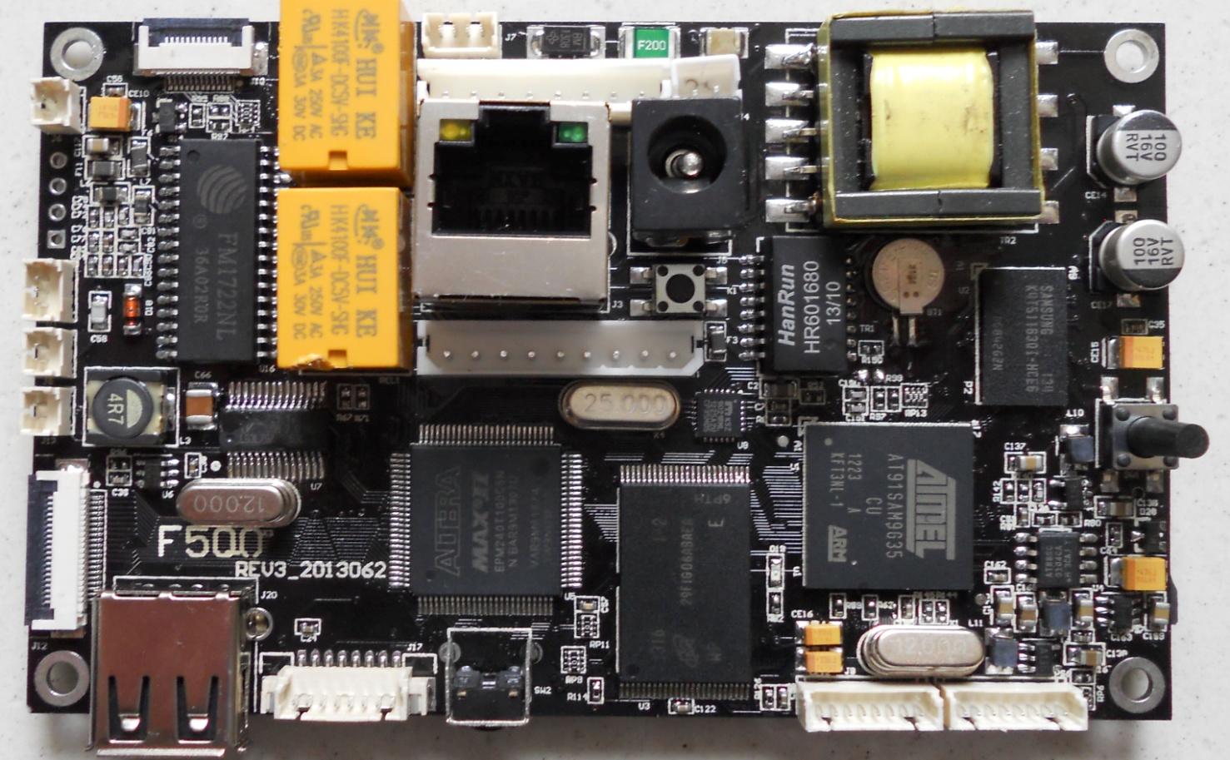
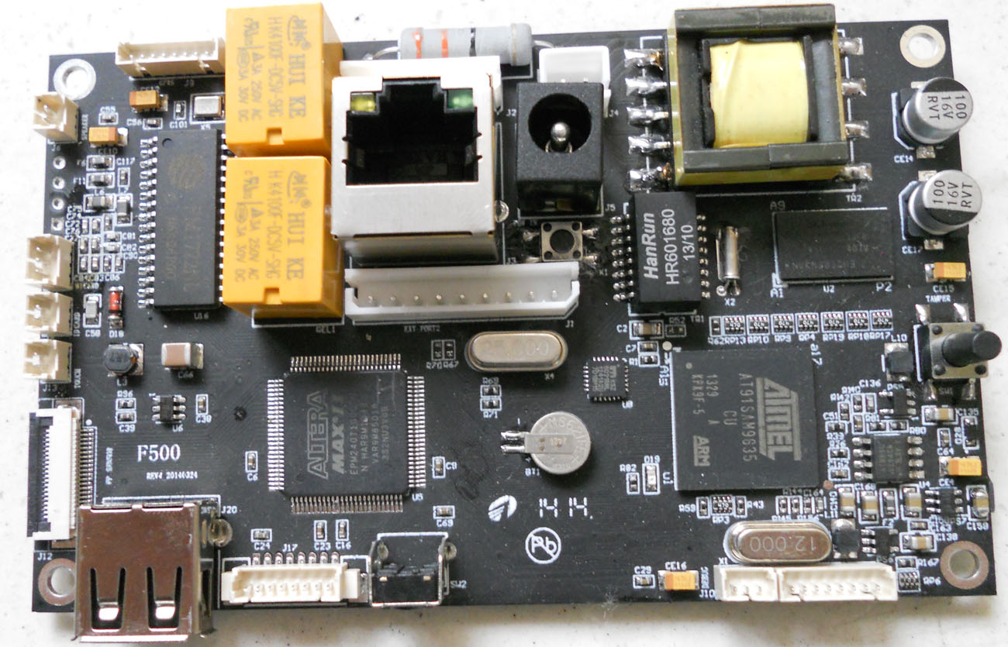
External Connector ,
”J1”,”J2”(2.5mm pitch)
Network ConnectorJ3
Tamper Switch SW1
Power supply
connector J5
(1.25mm pitch/3pin)
Battery connector J4

Speaker J6
M1 Card
antennaJ11
Refresh button K1
FingerPrinterSensorconnectorJ12(0.5mm pitch/20pin)

RESET SW2
USB HOST J20
125KHz EM Card antenna
J8
GPRS connector J9
Finger printer touch sensor connector J13
Fig 1. Front-Side
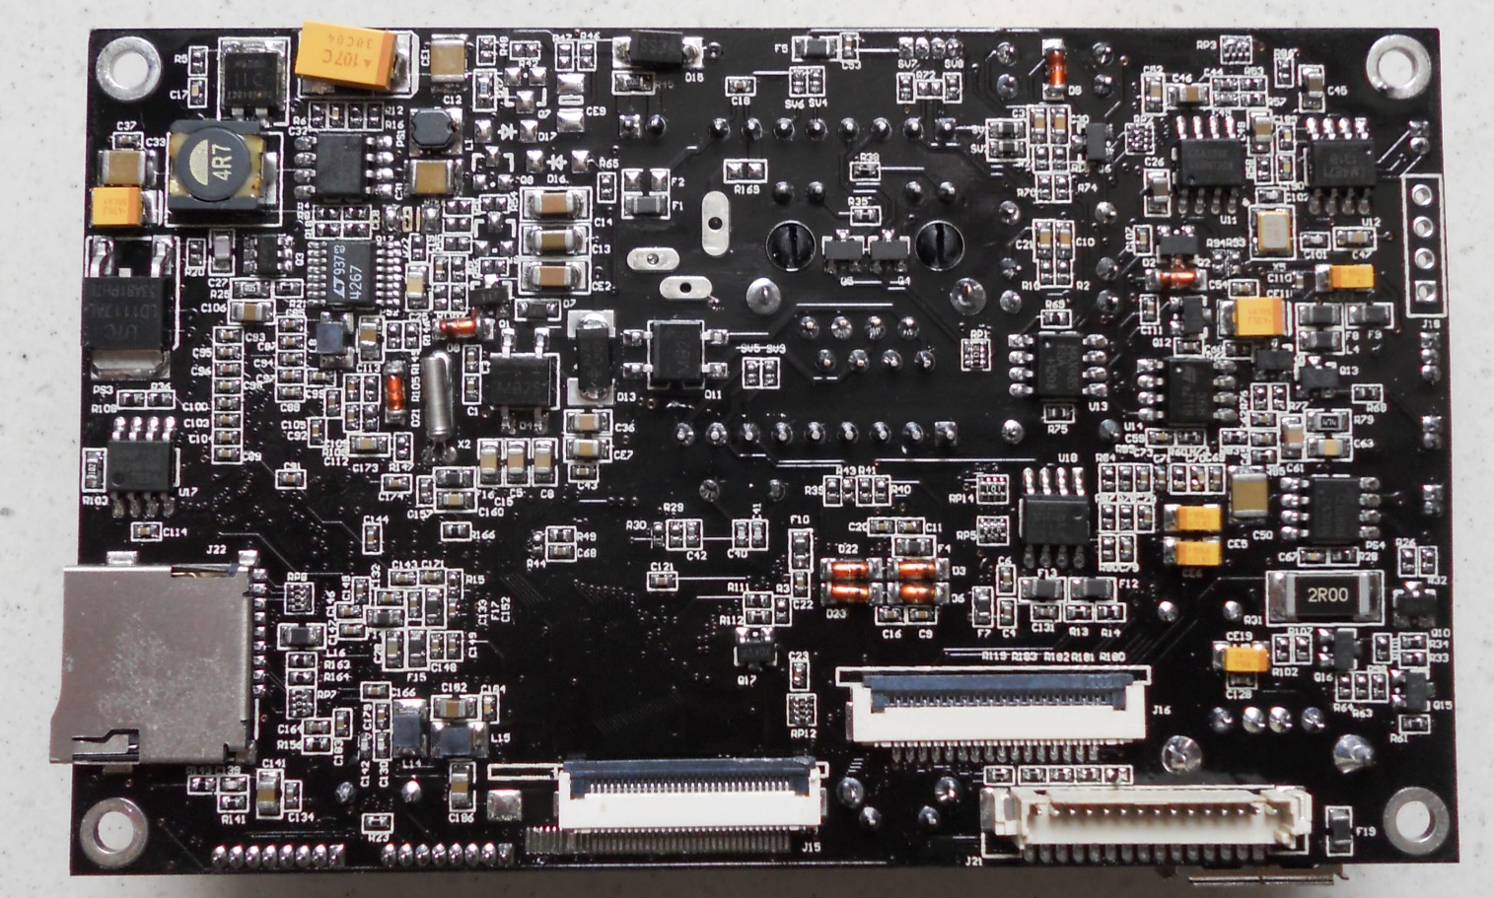
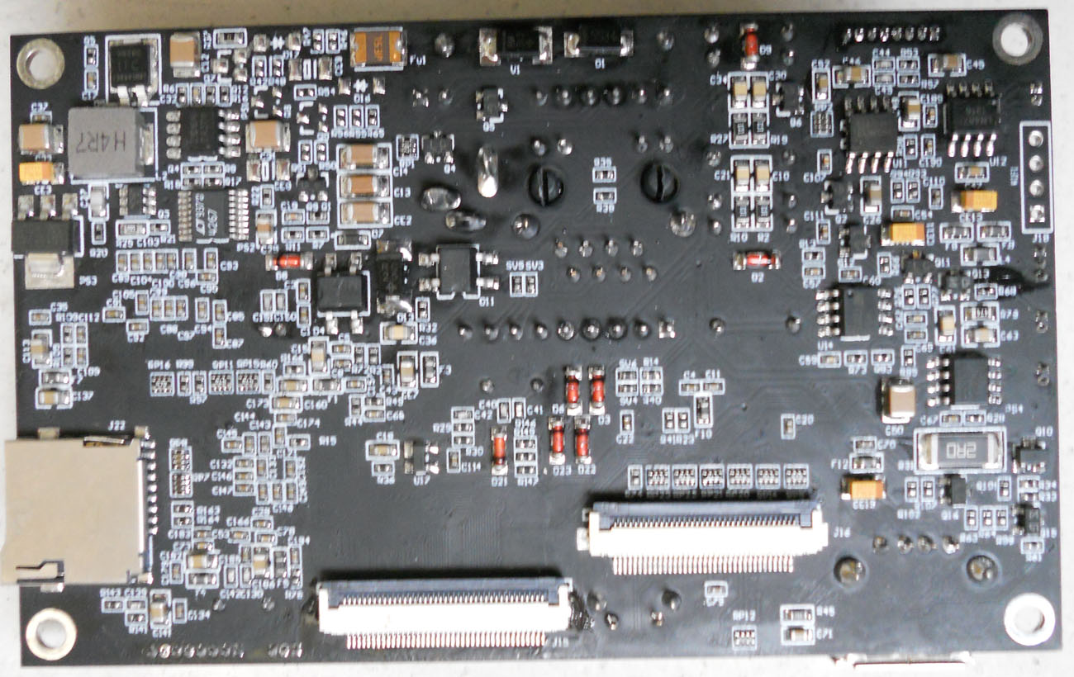
WIFI module connector J18
SD Card
connector J22

LCD connector
40 pin J15

CAMERA 36pin connector J16
Fig 2. Backside

Connector Note

-J1 (External Connector)
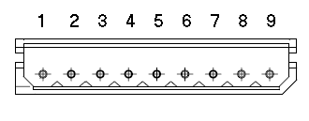2.5mm pitch/9pin vertical connector
Pin | Name | I/O | Description
1 | LOCK_NC | - | Lock relay’s N.C(normal close) terminal.
2 | LOCK_COM | - | Lock relay’s COM(common) terminal.
3 | LOCK_NO | - | Lock relay’s N.O(normal open) terminal.
4 | BELL_NC | - | Bell relay’s N.C(normal close) terminal
5 | BELL_COM | - | Bell relay’s COM(common) terminal.
6 | BELL_NO | - | Bell relay’s N.O(normal open) terminal.
7 | Door Sensor | I | Door open/close state Sensor
8 | Exit_In | I | Door Exit button input signal.
9 | GND |  | Power ground.

-J2 (External Connector)
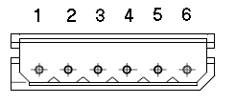2.5mm pitch/6pin vertical connector
Pin | Name | I/O | Description
1 | POW_IN | - | 12V POWER IN
2 | GND | - | GND
3 | WGNOUT1 | O | WiegandOutput Signal1,  open drain output
4 | WGNOUT0 | O | WiegandOutput Signal0,  Open drain output
5 | WGNIN1 | I | Wiegand input1. Internally pull up.
6 | WGNIN0 | I | Wiegand input0. Internally pull up.

-J3 (LAN Connector)
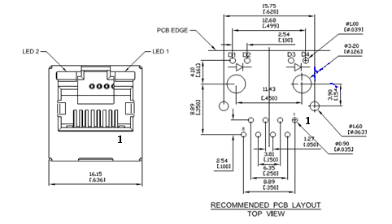RJ45V
vertical RJ-45 connector
Pin | Name | I/O | Description
1 | TX+ | O | Transmit +
2 | TX- | O | Transmit -
3 | RX+ | I | Receive +
4 | SPARE+ |  | SPARE+
5 | SPARE+ |  | SPARE+
6 | RX- | I | Receive -
7 | SPARE- |  | SPARE-
8 | SPARE- |  | SPARE-
9 | Yellow_LED+ | + | Yellow_LED+
10 | Yellow_LED- | - | Yellow_LED-
11 | Green_LED+ | + | Green_LED+
12 | Green_LED- | - | Green_LED-

-J4 ( Battery connector)
It can use this connector when internal battery is used.
Pin | Name | I/O | Description
1 | GND | - | BATTERY -
2 | BAT_IN | - | BATTERY +

-J5 (Power supply connector)Power Jack

Power supply connector.It must be supplied by DC 12V/1.5A.
Pin | Name | I/O | Description
1 | +12V | - | +12V
2 | GND | - | GND
3 | GND | - | GND

-J6 (Speaker connector)
Pin | Name | I/O | Description
1 | Sound1 | O | speaker output 1
2 | Sound2 | O | speaker output 2

-J8(Antenna Coil)
This module supports 125KHz ID card read function.
It only needs to connect antenna coil.
Inductance of antenna is 680uH. (Refer to “ID card Antenna Note”)

Pin | Name | I/O | Description
1 | ANT1 | - | Antenna Coil 1
2 | ANT2 | - | Antenna Coil 2

ID card Antenna Note
1. Electrical parameter
Inductance: 680uH (tolerance: +/-5%)
Resistance< 10 ohm
Frequency: 125 KHz
Max voltage: 150V
2. Mechanical size
It may be made on any size using following equation.

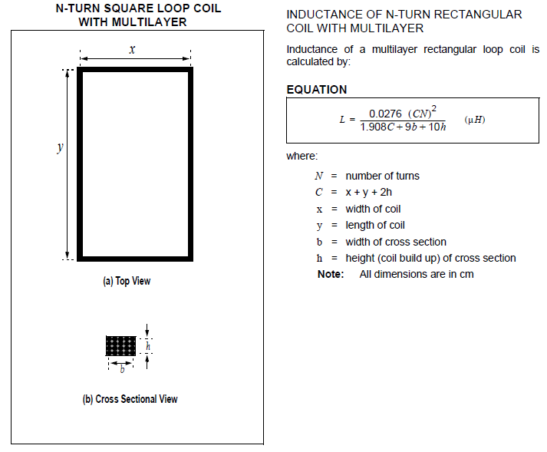
Example size:
N: 66, x: 55mm, y: 65mm, b: 2.0mm, h: 1.0mm (line diameter: 0.2mm)
C= 5.5+6.5+2*0.1=12.2

L =0.0276*(12.2*66)^2/(1.908*12.2+9*0.2+10*0.1)=686.2(uH)

-J9 (GPRS module connector)
** GPRS will not be supported in trial products. It is reserved for future use **
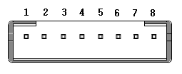1.25mm pitch /8pin
Pin | Name | I/O | Description
1 | 5V | - | +5V Power
2 | GPRS_TX | O | UART TX Signal
3 | GPRS_RX | I | UART RX Signal
4 | GND | - | Power ground
5 | nRESET | O | nRESET output
6 | GPRS_IO_0 | I | CTSinput/Debug UART TX
7 | GPRS_IO_1 | O | RTS output/Debug UART RX
8 | 3.3V | - | +3.3V Power

-J11(M1 Card) antenna connector
This module supports 13.56MHz M1 card.
It only needs to connect antenna .
Pin | Name | I/O | Description
1 | ANT1 | - | Antenna terminal 1
2 | RFGND | - | RF Ground
3 | ANT2 | O | Antenna terminal 2

-J12(OPT16 20pinSensor)
It is a fingerprint sensor (Slave) connector.0.5mm pitch/20pin FPC connector

-J13 (Finger printer sensor Touch Sense)
It is to detect finger proximity to fingerprint sensor.
Pin | Name | I/O | Description
1 | S_TOUCH | - | Sense Electrode
2 | S_TOUCH | - | Sense Electrode

The electrode area is typically 20mm*20mm.
Also the electrode is located as close as possible to where finger approach optical sensor.
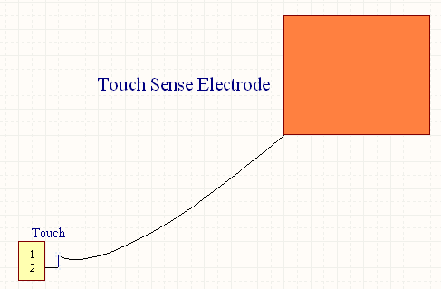
Mounting Example:
Inside case Finger proximity outside
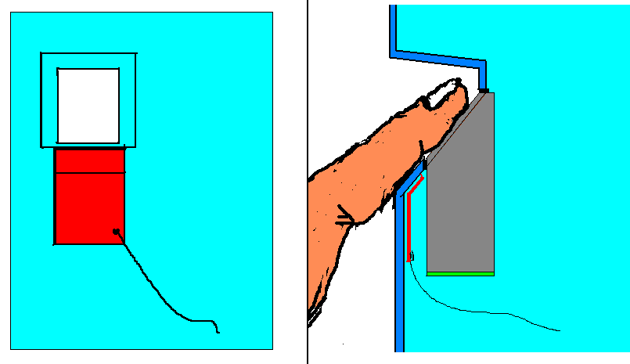

- J15 (LCD Connector)
0.5mm pitch/40pin connector

- J16(VR/IR Camera connector)
0.5mm pitch/36pin FPC connector

- J18 (USB connector for WIFI module)
** WIFI will not be supported in trial products. It is reserved for future use **

Pin | Name | I/O | Description
1 | USB power | - | 5V
2 | USB_DN | - | D-
3 | USB_DP | - | D+
4 | GND | O | Ground

- J20 (USB Disk/USB Device)
It can manage a USB disk.
Pin | Name | I/O | Description
1 | USB power | - | 5V
2 | USB_DN | - | D-
3 | USB_DP | - | D+
4 | GND | O | Ground

- J22 (SD card)

-K1 (Refresh)
This button is for refresh initial state.

-SW1 (Tamper)
This button is for preventing to remove the device.

-SW2 (Reset)
This button is for resetting the device.

